Question
Using MATLAB/Scilab, plot the impedance 100 + j50 Ω on a Smith chart with Z₀ = 50 Ω. Determine its normalized impedance, reflection coefficient and SWR.
Scilab Code:
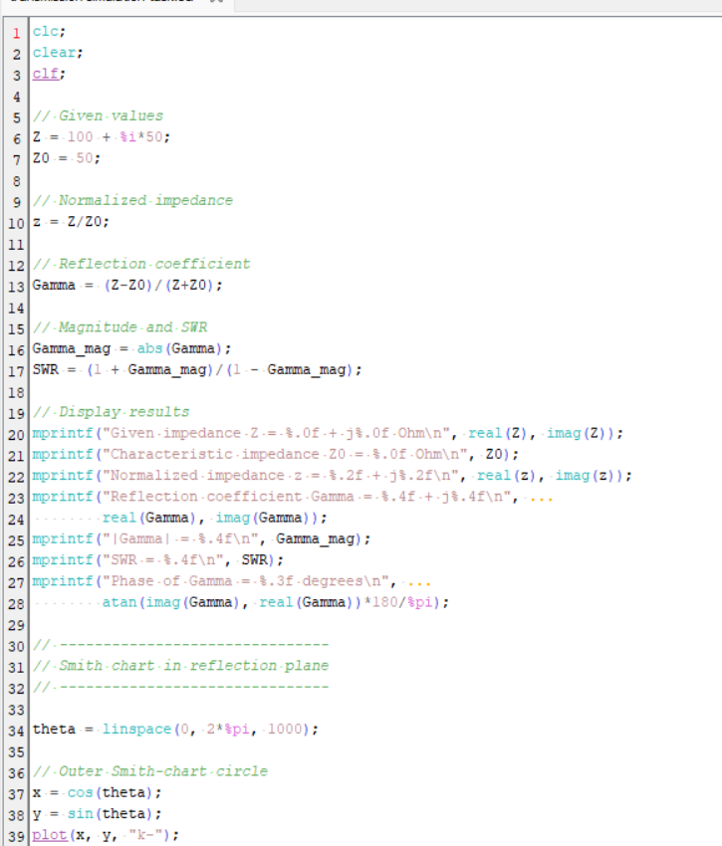
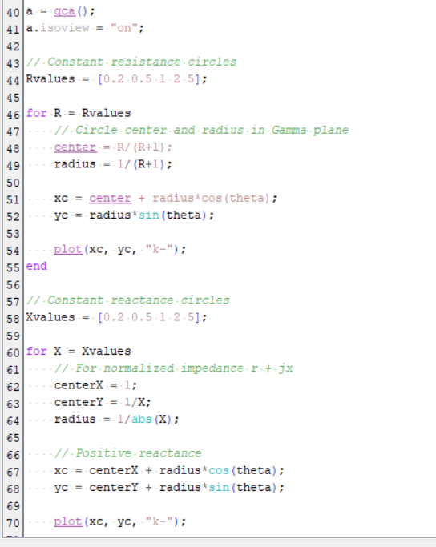

Expected Output
Given impedance Z = 100 + j50 Ohm
Characteristic impedance Z0 = 50 Ohm
Normalized impedance z = 2.00 + j1.00
Reflection coefficient Gamma = 0.4000 + j0.2000
|Gamma| = 0.4472
SWR = 2.6180
Phase of Gamma = 26.565 degrees
OUTPUT:
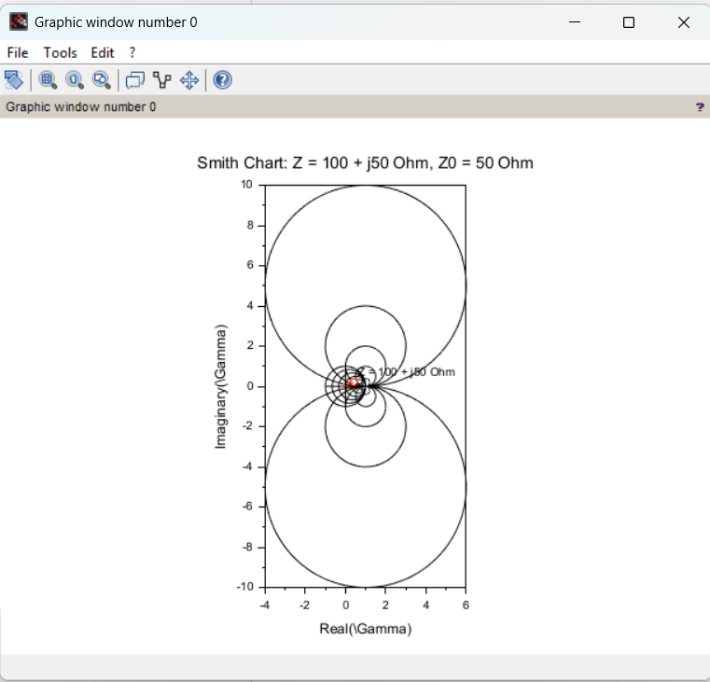

Result
For Z=100+j50Ω and Z0​=50Ω:
- Normalized impedance: z=2+j1​
- Reflection coefficient: Γ=0.4+j0.2​
- Magnitude of reflection coefficient: ∣Γ∣=0.4472​
- Phase: 26.565∘​
- SWR: 2.618≈2.62:1​
Smith chart result: The impedance 100+j50Ω is plotted at the point corresponding to z=2+j1, or Γ=0.4+j0.2.

